[In subject line insert: Have you discussed your wishes with loved ones?]
“It was the best gift I could have received.”
This comment is heard often from family members when their loved ones plan ahead of time. You can help alleviate the burden of them having to make difficult decisions during a time of grief by prearranging your final wishes.
You won’t have to worry about how you’ll be remembered or if loved ones will honor your memory and whether or not the decisions they’re asked to make align with your beliefs.
We’re here to support you through this process and ensure that your final wishes are carried out. Please join us for an informational seminar to learn more about how you can leave this lasting gift to those you love.
[Title of event]
Hosted by:
[Firm Name]
Presented by:
[Counselor Name]
[Title, Company]
[Mobile: ]
[Email address: ]
Date: [Day of the week, Month, Day, Year]
Time: [X:XX a.m./p.m.]
Location: [Venue Name]
[Street Address]
[City, State, Zip]
[Refreshments/Breakfast/Lunch/Dinner will be served]
While this event is free, reservations are required due to limited seating.
Guests are welcome.
Please RSVP by calling [Name] at [(XXX) XXX-XXXX] or emailing [email address].

[In subject line insert: Have you discussed your wishes with loved ones?]
“It was the best gift I could have received.”
This comment is heard often from family members when their loved ones plan ahead of time. You can help alleviate the burden of them having to make difficult decisions during a time of grief by prearranging your final wishes.
You won’t have to worry about how you’ll be remembered or if loved ones will honor your memory and whether or not the decisions they’re asked to make align with your beliefs.
We’re here to support you through this process and ensure that your final wishes are carried out. Please join us for an informational seminar to learn more about how you can leave this lasting gift to those you love.
[Title of event]
Hosted by:
[Firm Name]
Presented by:
[Counselor Name]
[Title, Company]
[Mobile: ]
[Email address: ]
Date: [Day of the week, Month, Day, Year]
Time: [X:XX a.m./p.m.]
Location: [Venue Name]
[Street Address]
[City, State, Zip]
[Refreshments/Breakfast/Lunch/Dinner will be served]
While this event is free, reservations are required due to limited seating.
Guests are welcome.
Please RSVP by calling [Name] at [(XXX) XXX-XXXX] or emailing [email address].

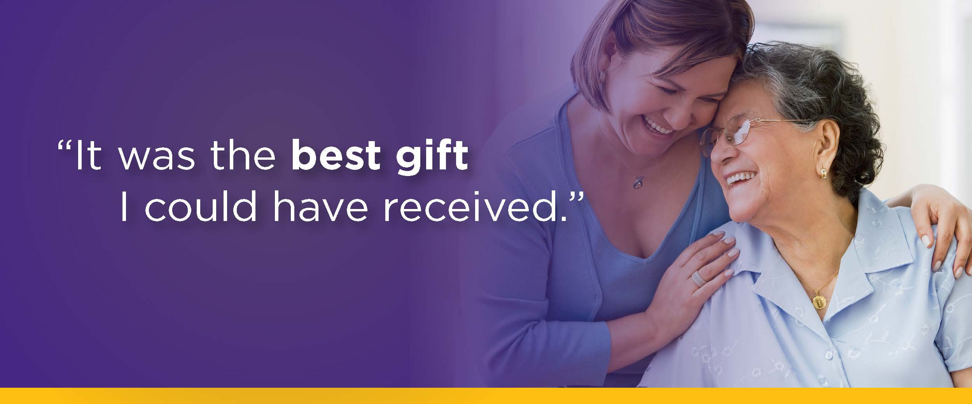

[In subject line insert: Have you discussed your wishes with loved ones?]
“It was the best gift I could have received.”
This comment is heard often from family members when their loved ones plan ahead of time. You can help alleviate the burden of them having to make difficult decisions during a time of grief by prearranging your final wishes.
You won’t have to worry about how you’ll be remembered or if loved ones will honor your memory and whether or not the decisions they’re asked to make align with your beliefs.
We’re here to support you through this process and ensure that your final wishes are carried out. Please join us for an informational seminar to learn more about how you can leave this lasting gift to those you love.
[Title of event]
Hosted by:
[Firm Name]
Presented by:
[Counselor Name]
[Title, Company]
[Mobile: ]
[Email address: ]
Date: [Day of the week, Month, Day, Year]
Time: [X:XX a.m./p.m.]
Location: [Venue Name]
[Street Address]
[City, State, Zip]
[Refreshments/Breakfast/Lunch/Dinner will be served]
While this event is free, reservations are required due to limited seating.
Guests are welcome.
Please RSVP by calling [Name] at [(XXX) XXX-XXXX] or emailing [email address].

[In subject line insert: Have you discussed your wishes with loved ones?]
“It was the best gift I could have received.”
This comment is heard often from family members when their loved ones plan ahead of time. You can help alleviate the burden of them having to make difficult decisions during a time of grief by prearranging your final wishes.
You won’t have to worry about how you’ll be remembered or if loved ones will honor your memory and whether or not the decisions they’re asked to make align with your beliefs.
We’re here to support you through this process and ensure that your final wishes are carried out. Please join us for an informational seminar to learn more about how you can leave this lasting gift to those you love.
[Title of event]
Hosted by:
[Firm Name]
Presented by:
[Counselor Name]
[Title, Company]
[Mobile: ]
[Email address: ]
Date: [Day of the week, Month, Day, Year]
Time: [X:XX a.m./p.m.]
Location: [Venue Name]
[Street Address]
[City, State, Zip]
[Refreshments/Breakfast/Lunch/Dinner will be served]
While this event is free, reservations are required due to limited seating.
Guests are welcome.
Please RSVP by calling [Name] at [(XXX) XXX-XXXX] or emailing [email address].

